Payment Request

- Purpose

When the customer fails to settle his account after the Second Notice, the CI/Collector or the Cashier will encode the Notice for Deposit and send a copy to the customer. When the customer agrees to deposit the unit for safekeeping while he/she secures the necessary funds to settle his/her overdue account, the CI/Collector will now encode the Payment Request.

- Views
  - List View
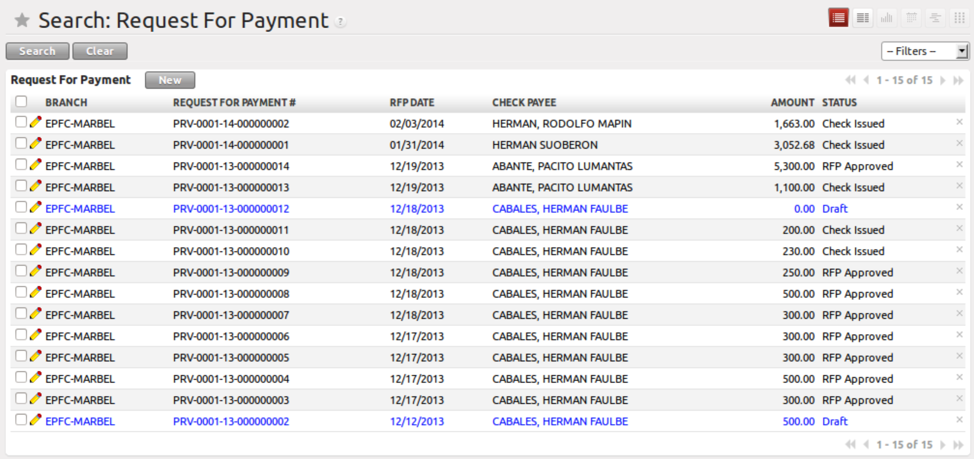
Figure 1. List view of Payment Request

  - Form View
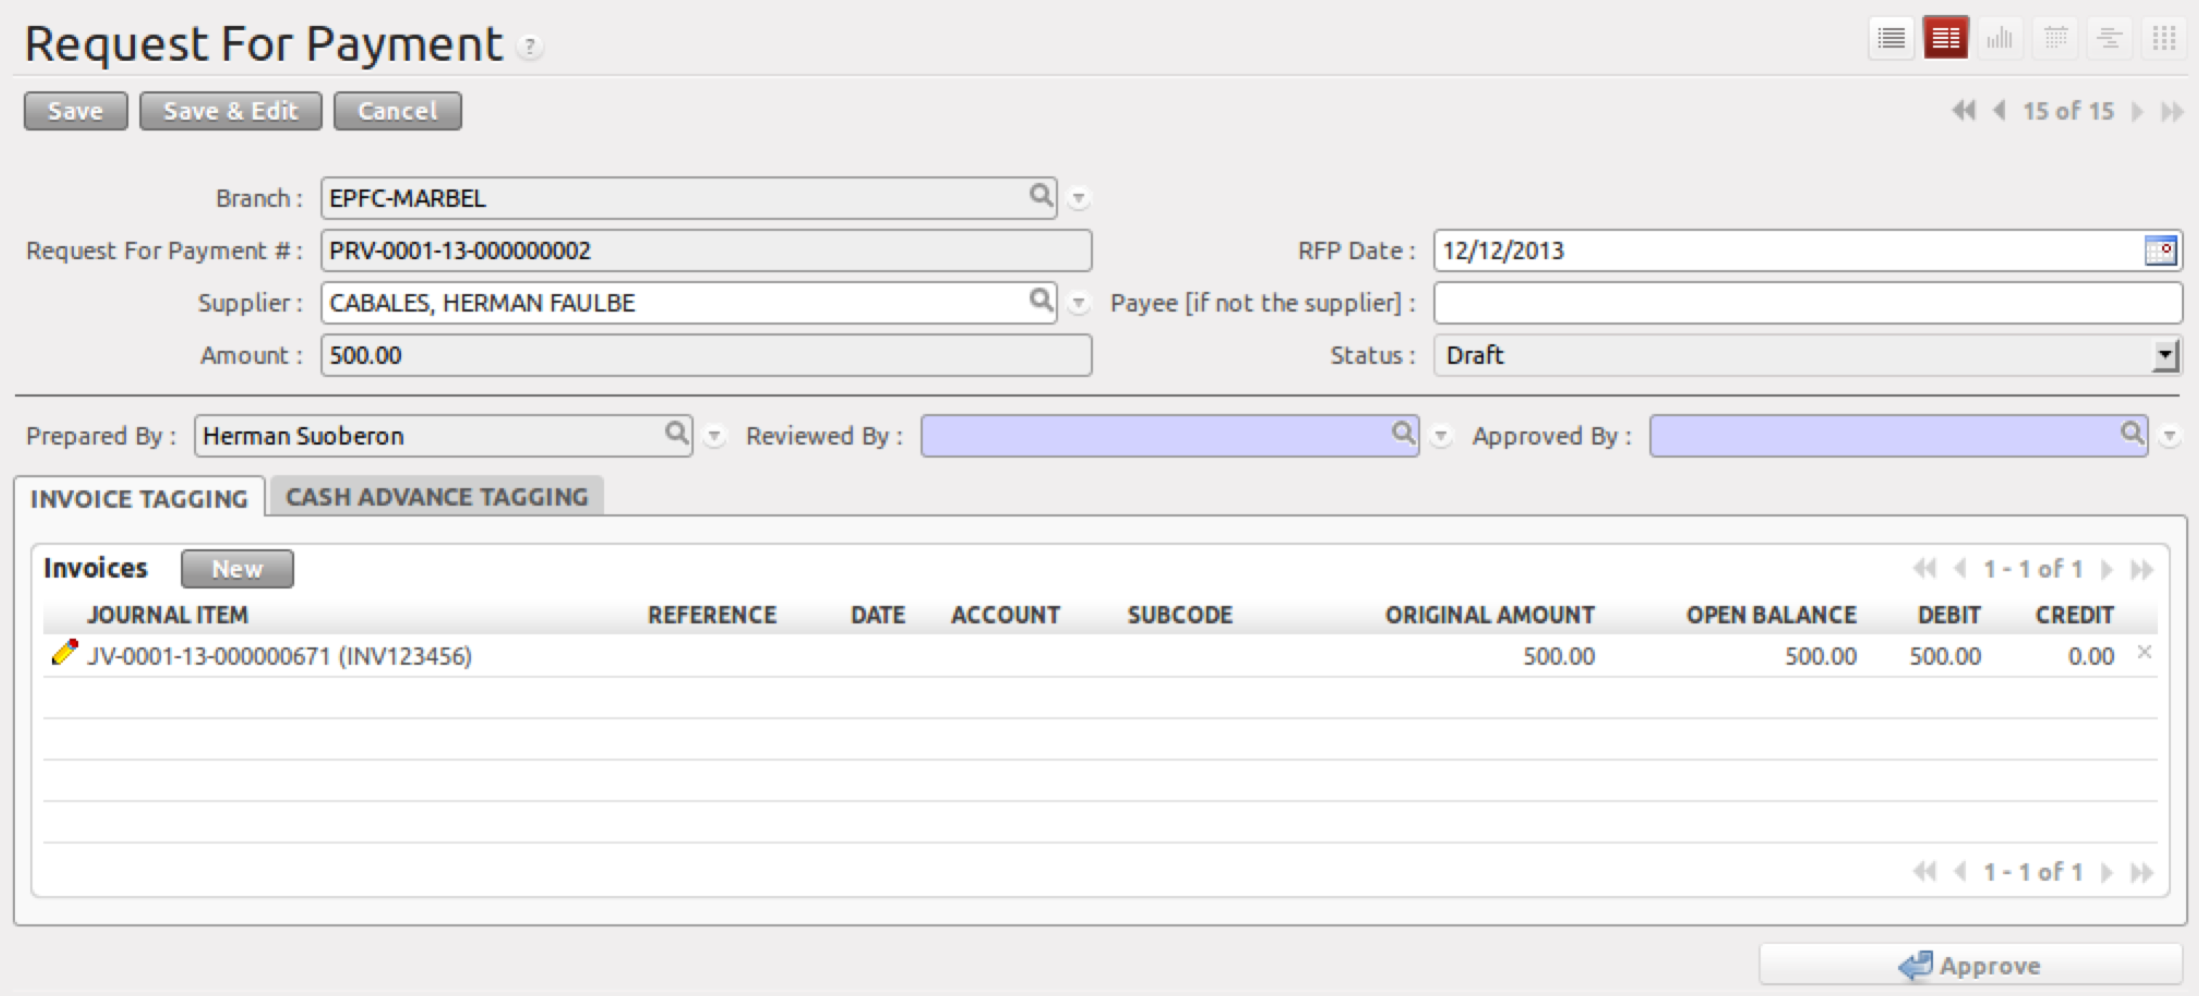
Figure 2. Form view of Payment Request

- Menu and Access Rights
  - Menu – Loan > MC Deposit > Payment Request
  - Access Rights
Role | Read | Write | Create | Delete
Receptionist | Yes | Yes | Yes | No
CI/Collector | Yes | Yes | Yes | No
Branch Manager | Yes | Yes | Yes | No

- Required Fields
All required fields can be easily distinguished from the form view. These are the fields highlighted in Figure 2.

- Date – date of request
- Supplier or Payee – name of supplier or payee
- Amount – this is automatically set when you add invoice lines
- Invoice Tagging – add applicable journal entries created in Accounts Payable Vouchers
- Reviewed By – name of the Treasury Manager
- Approved By – name of the Finance Head

- Workflow
Below is the list of states and visibility of the various buttons based on the record state:

Figure 3. Workflow of Payment Request

State | Description | Visible Buttons
Draft
Reviewed
Approved
Void
* for finalization

- User Action
Below is the list of user action available for specific users and its corresponding procedures:

Button | Action | Triggred By
Reviewed | No action | Treasury Manager
Approved | - A record in the Treasury > Check Voucher will be created with state ‘RFP Approved’ | Finance Head
Void | No action
*for finalization

- Field Visibility
All fields are visible.

- Reports and Print Outs

